BDM RURAL WATER SYSTEM CUSTOMER PAYMENT PORTAL GUIDE

Before you access the payment portal for the first time, be sure you have your bill for each of your hookups handy. You will need each account number to register the bills to your online account.

Go to bdm.epayub.com or use the link on our website www.bdmruralwater.com. The Log-In page looks like this:

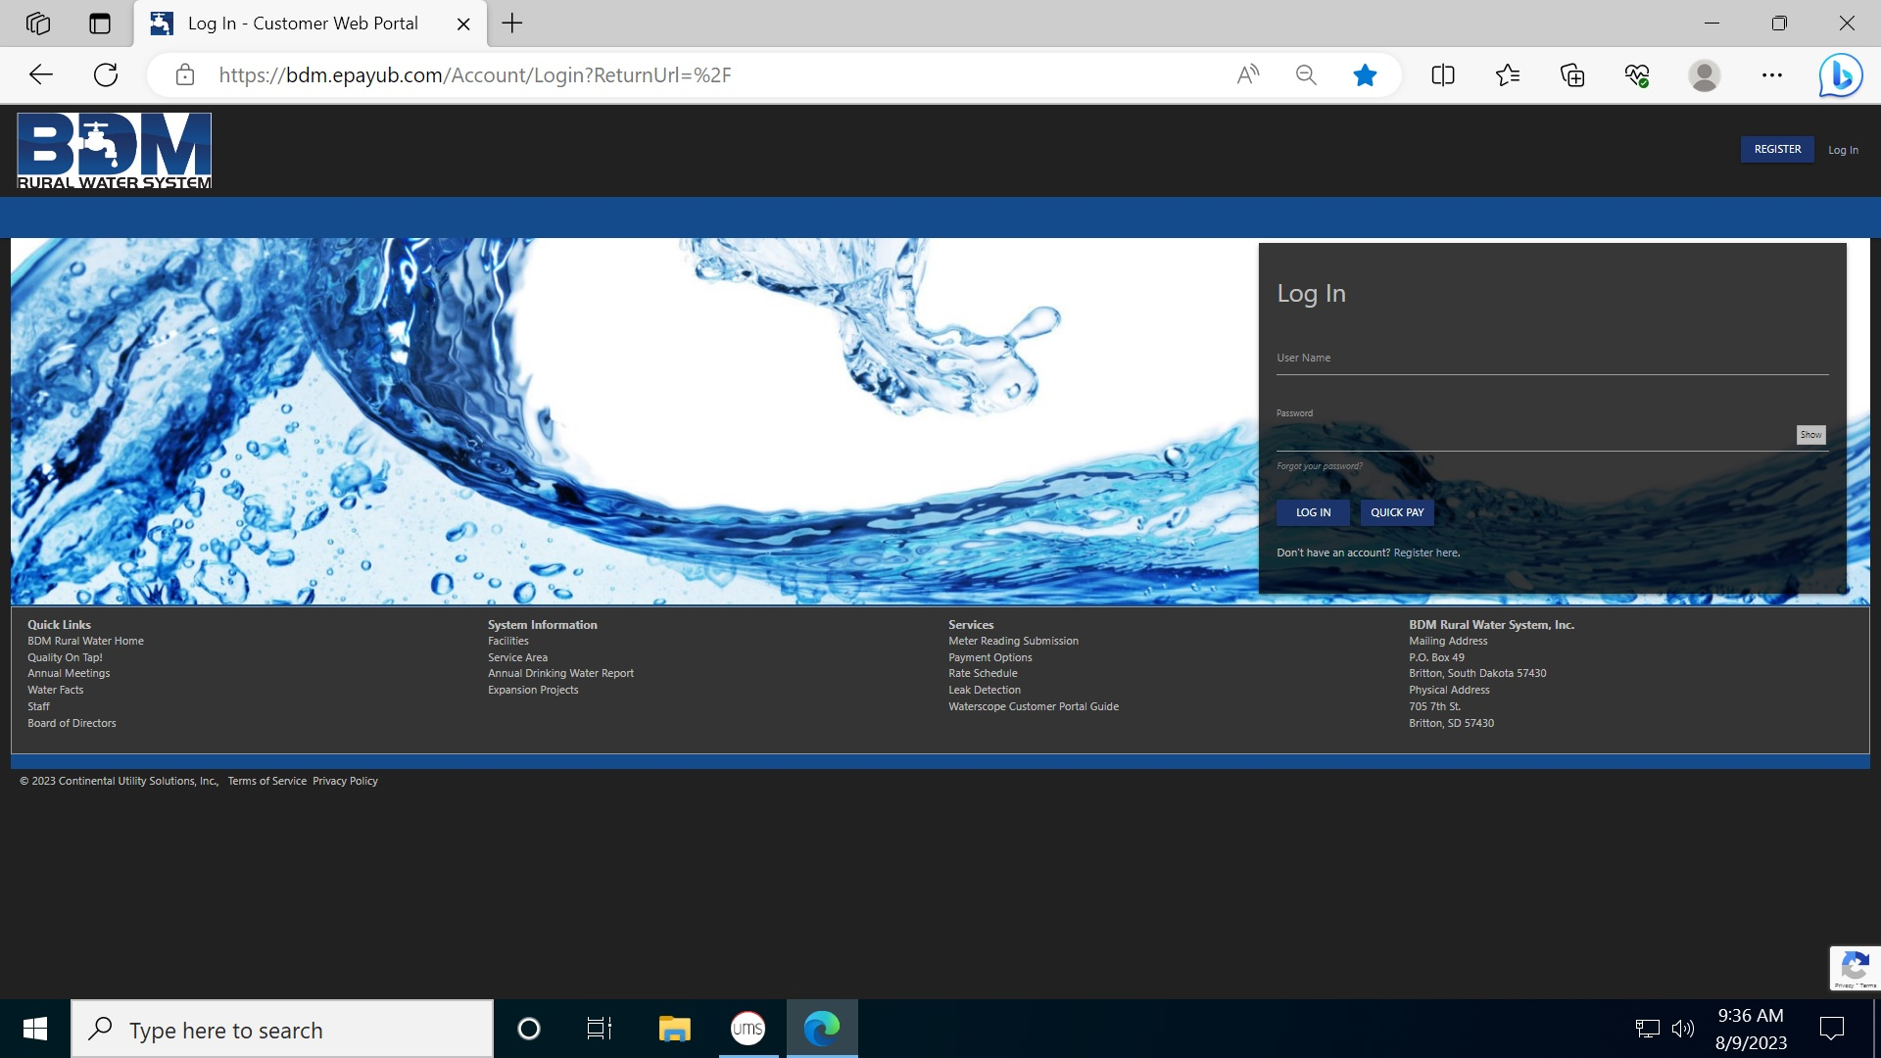

You may choose to register your account by clicking on “REGISTER” at the top right of the screen, or you can make a payment without registering your account by clicking on “QUICK PAY” at the center right of the screen. If you register, you will be asked to choose a user name and password. If you previously registered your account, you can simply enter your “LOG IN” information to access your account.
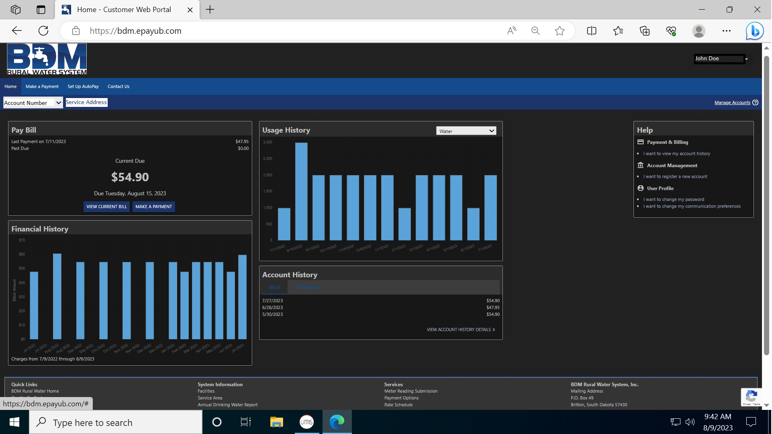

The Customer Account Home Page will give you an overview of your account. You can view past bills and payments, and usage history. If you have more than one account, click on “I WANT TO REGISTER A NEW ACCOUNT” on the right side of the screen.

To pay your bill, click on “MAKE A PAYMENT” on the left side of the screen. You will be taken to the following screen:
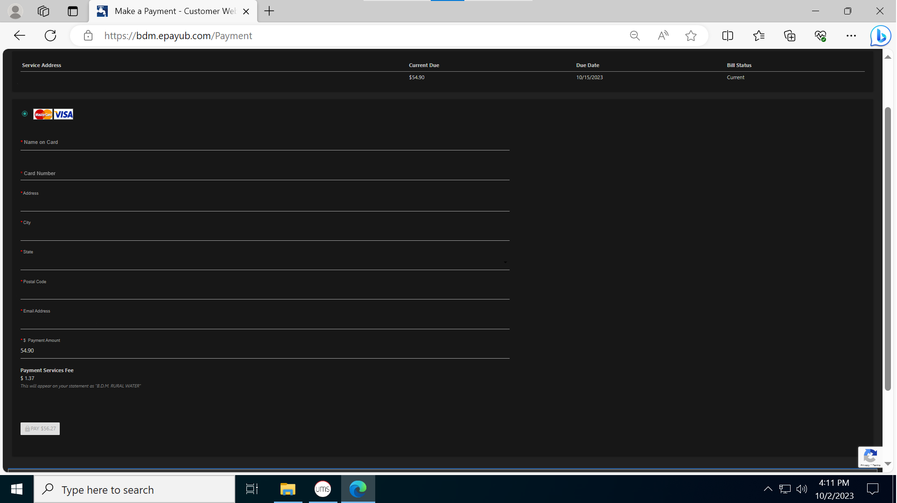

This is where you will enter your credit card and other billing information. The “PAYMENT AMOUNT” will automatically populate with your current amount due. You may change the payment amount if you wish. The 2.5% Payment Service Fee will be shown below the Payment Amount. Click on the “PAY $XX.XX button to make your payment.
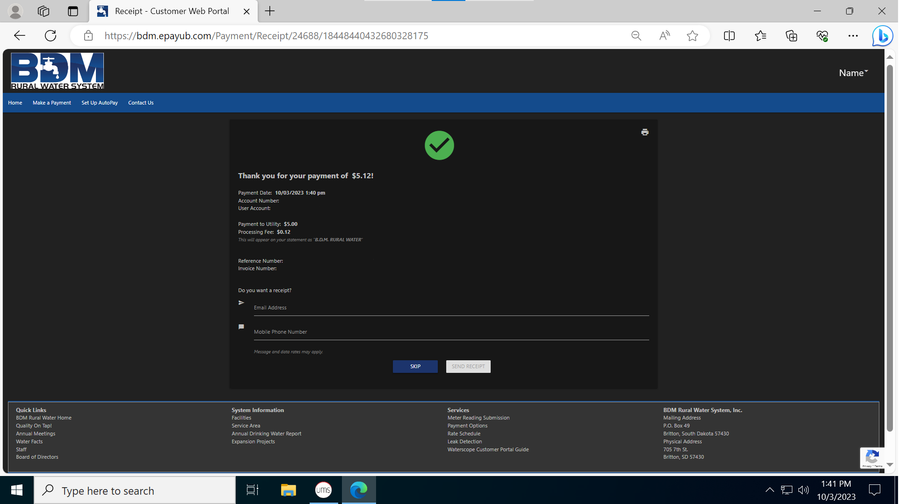

Once the payment is processed, you can print your receipt using the printer icon at the top right of the screen, or request one be emailed and/or texted to you.

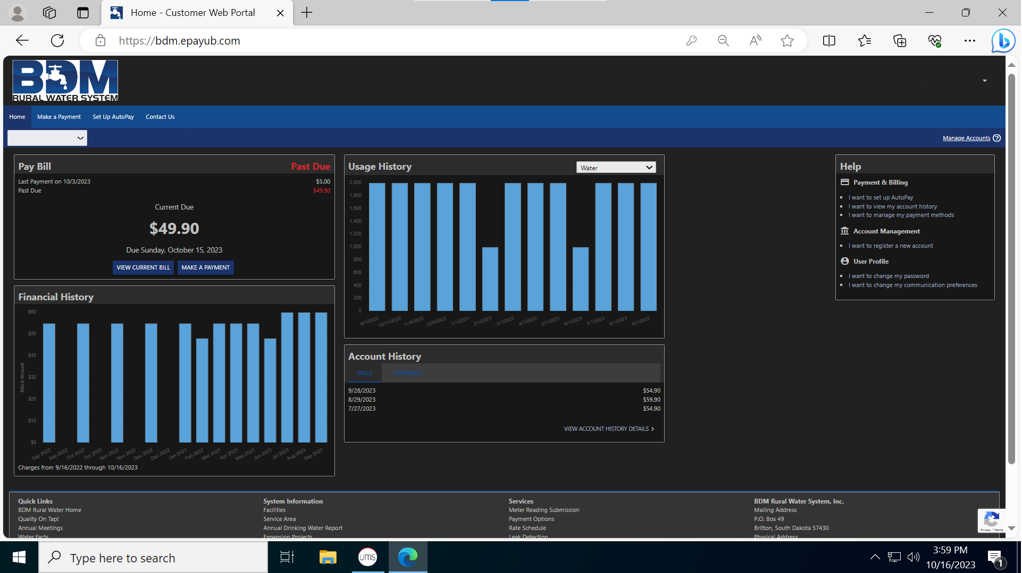

If you would like to set up recurring payments, from the home screen click on “I WANT TO SET UP AUTOPAY” on the right side of the screen, or “SET UP AUTOPAY” at the top left of the screen.

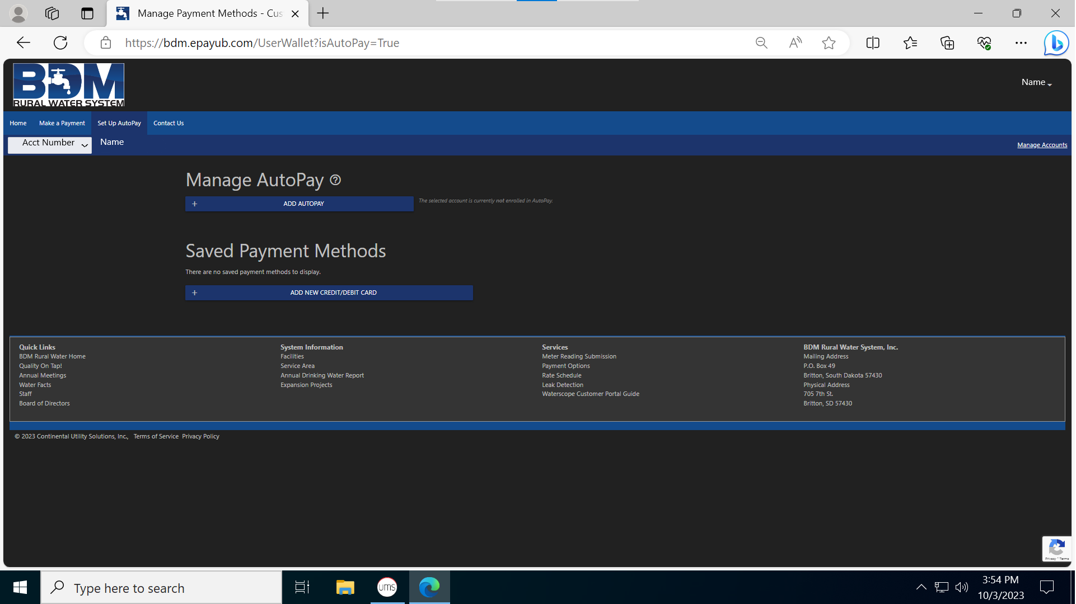

Click “ADD AUTOPAY” to set up your automatic payments.

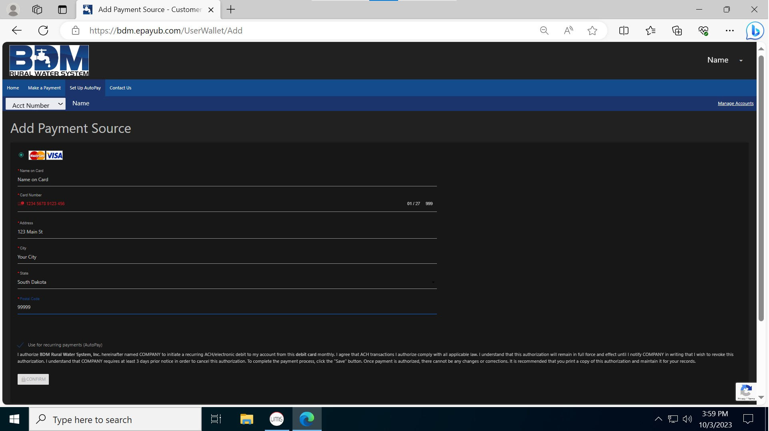

Enter card information and click “CONFIRM” at the bottom of the screen.

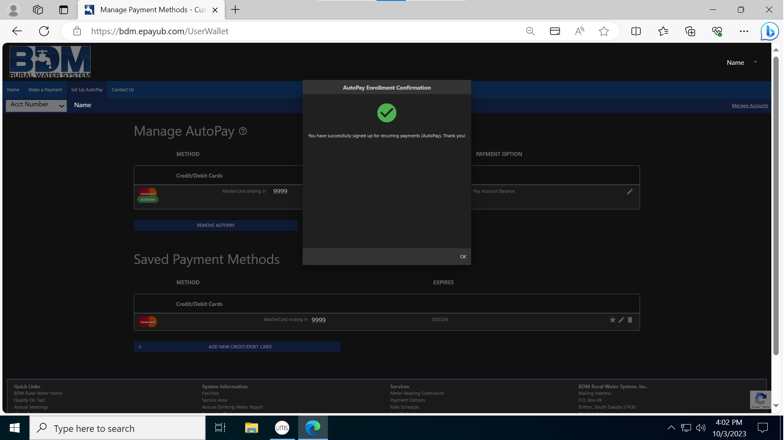

You will get a pop-up confirming your enrollment in Auto-Pay. Click “OK” in the pop-up to return to the Manage AutoPay screen. Your card will be charged on or near the 15th of the month. To update your card information, you can go to the Manage AutoPay screen and edit your card information. BDM will not notify you if your payment is declined. Please log into your online account and verify your bill was paid or call the office after the 15th of the month. Any bills not paid by the 22nd of the month will be charged a $10.00 late fee.

